Bipolar Evaluation
Part of our research was to do with examining coastal defences; these are the 4 we visited.
North Hallsands | Defence type: Rip Rap
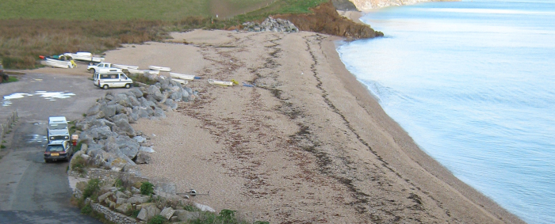
One of the least attractive, it helps to prevent flooding via stopping erosion. It’s not safe in any way, and could easily injure cd animals. You do have very good access to the beach compared to other coastal defences and the maintenance cost is quite low, the locals reported it didn’t disturb them much when they were implementing this coastal defence, because it was quite quick to put there.
North Hallsands Rip Raff
Beesands Village | Defence type: Sea Wall, Rock Armor, Gabions, etc.
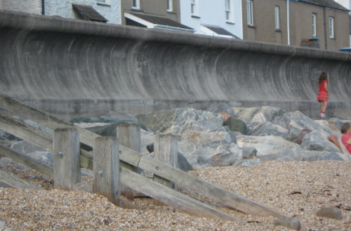
The Sea Wall was quite attractive; it goes 8 feet under the ground and has big boulders in front of the sea wall called Rock Armour. This is a long term defence solution, it is strong and prevents flooding very well but the Rock Armour supporting it is quite dangerous for younger children to play on because it would get quite slippery and there isn’t any stability so you’d easily fall off and injure yourself. It gives good access to the beach, although the maintenance costs are very high but you only have to repair them every 40 to 50 years. During the construction it would have been quite disturbing to the locals.
Beesands Village Sea Wall + Rock Armour
Slapton Sands | Defence type: Managed Retreat, Beach Nourishment
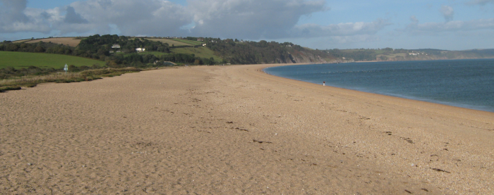
Slapton sands was very attractive in my opinion. It used no ‘Hard Management’ but rather used ‘Soft Management’ like the Managed retreat and Beach Nourishment schemes. ‘Managed Retreat’ works by moving the most vulnerable areas inland. The main reason for implementation of Managed Retreat is generally to improve coastal stability, essentially replacing artificial ‘hard’ coastal defences with natural ‘soft’ coastal landforms. This is also relatively inexpensive compared to other coastal defences
Slapton Sands: Notice the lack of ‘hard’ coastal defences
Sunnydale | Defence type: Gabions
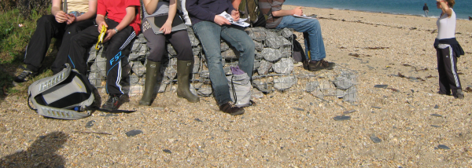
These Gabions were not very attractive to me personally but it was very cheap and maintenance was cheap and easy to repair and protected from beach recession. The access to the beach was very easy, the Gabions did not obstruct much at all, but they could be hazardous to children or animals as they’re not safe to play on.
Gabiones at Sunnydale

